

**Tribhuvan University**

Faculty of Humanities and Social Sciences

**Blogging System**

**A PROJECT REPORT**

**Submitted To:**

**Department of Computer Application**

**Ratna Rajyalaxmi Campus**

***In partial fulfillment of the requirement for the Bachelor in Computer Application***

**Submitted By:**

BISHAM RAJ PANDEY (6-2-40-15-2021)

BISHAL REGMI (6-2-40-14-2021)

**Under the Supervision of**

**Bipin Timilsina**



**Tribhuvan University**

Faculty of Humanities and Social Science

Ratan Rajya Laxmi Campus

# SUPERVISOR’S RECOMMENDATION

I hereby recommend that this project prepared under my supervision by BISHAM RAJ PANDEY and BISHAL REGMI entitled “Online Blogging System” in partial fulfillment of the requirements for the degree of Bachelor of Computer Application is recommended for the final evaluation.

________________________

Bipin Timilsina

SUPERVISOR

Department of Computer Application

Pradarshani Marg, Kathmandu



Tribhuvan University

Faculty of Humanities and Social Sciences

Ratan Rajya Laxmi Campus

# LETTER OF APPROVAL

This is to certify that the project prepared by BISHAM RAJ PANDEY and BISHAL REGMI entitled “Online Blogging System”, In partial fulfillment of the requirements for the degree of Bachelor in Computer Application has been evaluated in our opinion it id satisfactory in the scope and quality as a project for the required degree.

|  |  |
| --- | --- |
| **SIGNATURE of Supervisor**  -------------------------------------  Bipin Timilsina  Lecturer, Project Supervisor  Ranta Rajyalaxmi Campus | **SIGNATURE of HOD/Coordinator**  --------------------------------------------  Mr. Bhupendra Ram Luhar  Coordinator  Department of BCA  Ratna Rajyalaxmi Campus |
| **SIGNATURE of Internal Examiner**  ---------------------------------------- | **SIGNATURE of External Examiner**  **---------------------------------** |

# ACKNOWLEDGEMENT

The project detailed in the report was carried out and presented at Ratna Rajya Laxmi Campus, under the Faculty of Humanities and Social Sciences at Tribhuvan University of Technology, as a part of the Bachelor of Arts in Computer Application program. This project stands as evidence not only of technical skill but also of teamwork and performance in the face of various challenges. The successful completion of this endeavor is owed in large part to the invaluable assistance provided by experts.

Furthermore, we express our appreciation to the instructors of the Department of Computer Application for generously sharing their knowledge, which greatly contributed to the development of this project. We are also grateful to our friends for their steadfast support, and to the participants whose feedback helped improve our project.

We are deeply thankful to our supervisor, Mr. Bipin Timilsina, a lecturer whose guidance was instrumental in the success of this project. We also appreciate the support of our department coordinator, Mr. Bhupendra Ram Luhar.

Lastly, our heartfelt gratitude goes to our families, friends, and mentors. Without their unconditional love, care, and support, this achievement would not have been possible

# ABSTRACT

The purpose of the "Online Blogging System" is to make it easy for users to create and manage their blogs. This system aims to facilitate the creation of blogs, posting of comments, and moderator actions. The required software and hardware are readily available and easy to use. The system offers features like profile customization, allowing users to change their profile pictures and bio. Moderation tools are incorporated to maintain a safe and respectful online community, enabling moderators to review and delete comments, filter inappropriate content, and ensure adherence to guidelines.

The users in the system are able to create an account which they can use to vie blogs made by other people. The blogs that the user can see can be liked, commented or reported. The user can also edit their profile or post their own blog for others to read.

The moderators in the system are able to act the same as users, but have additional powers like the ability to delete posts, comments and user accounts. They can also lock or hid posts made by other users. The mods are controlled by a super admin who has the power to promote or demote moderators.

*Key Words:*

*Blogger*

*Moderator*

*Super admin*

*Blog-A post*

Contents

SUPERVISOR’S RECOMMENDATION i

LETTER OF APPROVAL ii

ACKNOWLEDGEMENT iii

ABSTRACT iv

Table of Figures vii

Table of Tables viii

CHAPTER 1: INTRODUCTION 1

1.1 Background 1

1.2 Problem Statement 1

1.3 Objectives 1

1.4 Scope and Limitation 2

1.4.1 Scope 2

1.4.2 Limitation 2

1.5 Report Organization 2

2 CHAPTER 2: BACKGROUND STUDY AND LITERATURE REVIEW 3

2.1. Background Study 3

2.2. Literature Review 3

3 CHAPTER 3: SYSTEM ANALYSIS AND DESIGN 5

3.1 System Analysis 5

3.1.1 Requirement Analysis 5

Non- 7

3.1.2 Feasibility Analysis 7

3.1.3 Data Modeling 9

3.1.4 Process Modeling 10

3.2 System Design 12

3.2.1 Architectural Design 12

3.2.2 Database Schema Design 13

3.2.3 Interface Design 14

3.2.4 Physical DFD 19

4 Chapter 4 IMPLEMENTATION AND TESTING 20

4.1 Implementation 20

4.1.1 Tools Used 20

4.1.2 Implementation Details of Modules 20

4.2 Testing 21

4.2.1 Test Cases for Unit Testing 21

4.2.1 Testing for account edit module: 23

4.2.2 Testing for account module 24

Test Cases for System Testing 25

5 Chapter 5 CONCLUSIONS AND FUTURE RECOMENDATION 26

5.1 Lesson Learnt 26

5.2 Conclusion 26

5.3. Future Recommendations 26

APPENDICES 27

6 Bibliography 29

7 29

# Table of Figures

Figure 1:Use Case Diagram for Blogging System 6

Figure 2:Gantt Chart of Blogging System 8

Figure 3:Entity Relation Diagram of Blogging System 9

Figure 4:Context Diagram of Blogging System 10

Figure 5:Level 1 DFD of Blogging System 11

Figure 6:CMS data module of Blogging System 12

Figure 7:Database Schema Design of Blogging System 13

Figure 8:UI Design of Login page of Blogging System 14

Figure 9:UI Design of Register page of Blogging System 15

Figure 10::UI Design of Display page of Blogging System 16

Figure 11::UI Design of Display-Post page of Blogging System 17

Figure 12::UI Design of Account page of Blogging System 18

Figure 13:Physical DFD of Blogging System 19

# Table of Tables

Table 1:Test case for Register module 21

Table 2:Test case for Login module 22

Table 3Test Case for Dispaly Post Module 22

Table 4:System Testing 25

# CHAPTER 1: INTRODUCTION

## Background

Online Blogging System is a system that offers a platform for users to share posts and information. This system allows readers to access blogs from wide range of topics including Entertainment, National and International events etc. The content on this site can be posted by anyone and will be moderated by the Moderators. The Online Blogging System is designed to address the limitations of other methods by providing a user-friendly web-based platform. Users do not need any specialized knowledge to use the system, making it accessible to a global audience. It serves as a valuable source of information for those seeking to gain information on specific topics as well as wanting to record their thoughts and ideas and share them with the world.

## Problem Statement

The emergence of blogging systems is prompted by several pressing issues in the current existing systems. Some of them are

* Difficulty in creating and reading blog posts
* Prevalence of dishonest information
* Difficulty in communication between users

## **Objectives**

The objectives of Online Blogging system are:-

* To Provide a platform to create and post blogs
* To Prevent inappropriate contents using user reports
* To Provide method to customize user accounts

## Scope and Limitation

### Scope

The scopes of Online Blogging system are:-

* Facilitate content creation
* Facilitate information sharing
* Help in communication with users

### Limitation

The limitations of Online Blogging system are:-

* Problems to upload multiple images at once
* Lack of monetization options for users

## Report Organization

The report can be organized into 5 chapters which are given below:

**CHAPTER 1:** Includes introduction includes the brief introduction of the system, statement of problem, objectives, scope and limitation.

**CHAPTER 2:** Includes background study and literature review includes the previous work related to the systems and similar works were studied and are summarized.

**CHAPTER 3:** Includes system analysis and design includes different feasibility analysis and designed system architecture, system flow diagram, dataflow diagram.

**CHAPTER 4:** Includes implementation and testing includes various implementation method and tools and also contains description of testing.

**CHAPTER 5:** Includes conclusion and future recommendations includes outcomes of the system, conclusion to the system and description about what features can be added in the future.

# 

# CHAPTER 2: BACKGROUND STUDY AND LITERATURE REVIEW

## 2.1. Background Study

Blogs, short for weblogs, are online platforms where individuals or groups can share their thoughts, opinions, and experiences in a chronological format. Dating back to the late 1990s, early blogging sites such as LiveJournal, Blogger, and WordPress paved the way for the popularity of blogging [1] as a form of personal expression and information dissemination. These platforms offered users the ability to publish content easily and interact with readers through comments and sharing features. Over time, blogging has evolved into a diverse and dynamic medium, with blogs covering a wide range of topics including lifestyle, fashion, technology, travel, and more. [2] Today, blogging remains a popular means of communication and storytelling, with modern platforms offering advanced features and customization options to cater to the needs and preferences of bloggers and readers alike. [3]

## 2.2. Literature Review

Blogging systems have undergone significant evolution since their inception in the late 1990s, transforming the landscape of online communication and content creation. Early platforms like LiveJournal, Blogger, and WordPress paved the way for the popularity of blogging as a mainstream medium for sharing thoughts, opinions, and experiences [4]. These platforms democratized content creation by offering simple yet effective tools for publishing and managing blogs.

User engagement and community building emerged as critical aspects of blogging platforms' success, with features like comments sections and social sharing buttons facilitating interaction and collaboration among users [5]. Additionally, the integration of social media functionalities into blogging platforms has further enhanced user engagement and content dissemination [3]

Monetization strategies have become increasingly important for bloggers seeking to generate revenue from their content. While advertising and affiliate marketing remain popular options, issues such as ad blockers and declining ad rates pose challenges to monetization efforts [6] .Moreover, accessibility barriers such as language and device compatibility may limit the reach and impact of bloggers, particularly in underserved regions. [7]

Overall, blogging systems continue to evolve in response to changing user needs, technological advancements, and cultural shifts. [2] By understanding the key themes and trends in the development and usage of blogging systems, researchers and practitioners can better address the challenges and opportunities facing this dynamic medium.

# CHAPTER 3: SYSTEM ANALYSIS AND DESIGN

## System Analysis

System analysis was performed on existing online blogging systems. The process of requirement gathering was performed and the system were studied. The various systems which were studied were analyzed and the systems which were able to be implemented were identified. Other popular systems were also analyzed and more ideas and inspiration were gathered from them.

### Requirement Analysis

Requirement analysis was performed by examining existing systems. Systems like blogger, medium and Quora were examined and studied to gather requirements for the system. Popular sites like Instagram and Facebook were also studied for their layout and features they implement. The gathered requirements were filtered and the systems which were able to be implemented were sorted out.

#### Functional Requirement

The online blogging system must have the ability to create user accounts. The accounts which are created can be of three categories, which are users, moderators and super admins. All three of the accounts have the ability to post a blog, read other's blog, like blogs, report inappropriate blogs, comment on blogs and reply to the comment on blogs. They also have the ability to follow people and have the facility to see the people who have followed them back. All three types of account also share the ability to edit their blogs as well as their profiles, by changing the provided information. They can also delete their own blogs and comments. The moderators and super admins of the system have the ability to strike users for misconduct. They also have the ability to lock or hide blogs which have been posted along with unhiding or unlocking the blogs. They also share the ability to delete user's account. The super admin has the ability to promote or demote users.

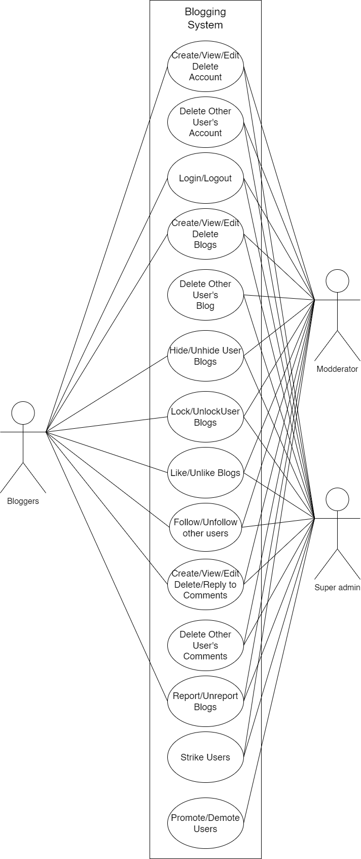

Figure :Use Case Diagram for Blogging System

#### **Non**-Functional Requirement

Non-functional requirements of the system are

* Performance: The system should be responsive and able to handle a large number of concurrent users without significant slowdowns or interruptions. This includes fast loading times for web pages, quick response to user interactions, and efficient database queries.
* Security: The system should have robust security measures in place to protect user data, prevent unauthorized access, and mitigate potential security threats such as hacking or data breaches. This includes implementing encryption protocols, secure authentication mechanisms, and regular security audits.
* Scalability: The system should be designed to accommodate growth in both user base and content volume over time. This involves ensuring that the infrastructure can scale horizontally by adding more servers or resources as needed, as well as optimizing code and database structures to handle increased load without sacrificing performance.

### Feasibility Analysis

A feasibility study aims to objectively and rationally uncover the strengths and weaknesses of an existing business or proposed venture, opportunities and threats present in the natural environment, the resources required to carry through, and ultimately the prospects for success.

#### Technical Feasibility

The online blogging system is deemed to be technically feasible. The use of HTML and CSS to create the basic layout of the webpage is both simple and easy to understand. The use of PHP as the backend language helps to easily communicate with the MySQL database which is used. Due to the familiarity with the languages, the system is said to be technically feasible under the current circumstances.

#### Operational Feasibility

An online blogging system shows strong operational feasibility. It addresses key user needs by providing an easy platform for content creation and sharing. Users can post blogs, where other users can read the blogs. Features like comments and replies improve the system's effectiveness. These tools help to create a community interaction. Features like reports also make the system effective.

* The current system provides good response time.
* The organization will gain significant benefits from the proposed system.
* The resources available are used to the maximum capacity to deliver quality system on time.

#### Economic Feasibility

The online blogging system is deemed to be economically feasible. This is because the cost of development and maintenance can be recovered by the system.

* The system is cost effective
* The efficient management of resources will lower the cost of this system
* The benefits of this system will outweigh the costs.

#### Scheduling Feasibility

This seeks to assess the time that the proposed system will take to develop and implement.

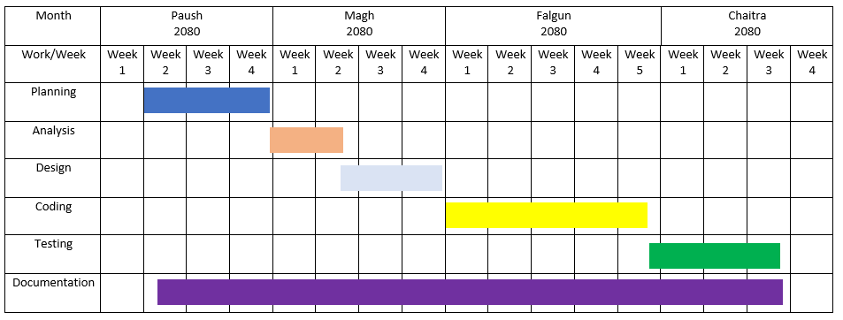 Figure :Gantt Chart of Blogging System

### **Data Modeling**

Figure :Entity Relation Diagram of Blogging System

The Entity Relation diagram of the Blogging system is shown above. This Diagram shows the relationship between the various databases of the blogging system. The blogging system contains total of seven tables. The Login table and the Account table have a one-to-one relation. The posts table has a one-to-many relation with three other tables like the comment table, likes table, report table. The account table also has a one to many relation with the follower table. All of the table have the column "id" as a primary key, which helps to uniquely identify the table.

### Process Modeling

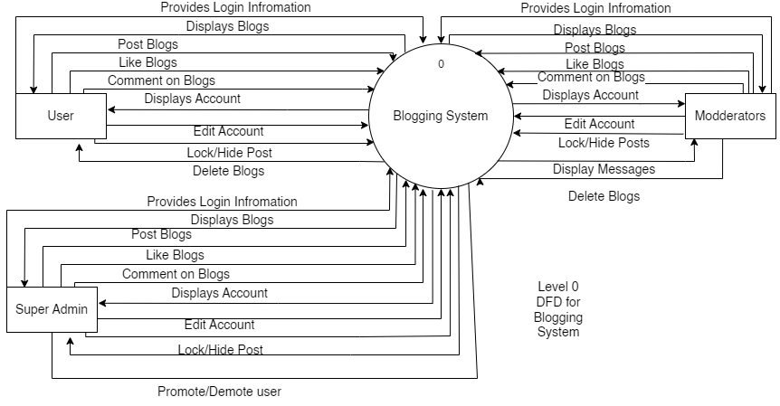

Figure :Context Diagram of Blogging System

The context diagram of the Blogging system is given above. The level 0 Diagram gives us a general overview of the processes the users can perform in this system. All of the users, can perform the functions of logging in, posting, editing and deleting blogs and commenting. The moderators and the super admins have the power to delete the blogs and comments of other users. The super admins have the power to promote and demote the users to other positions.

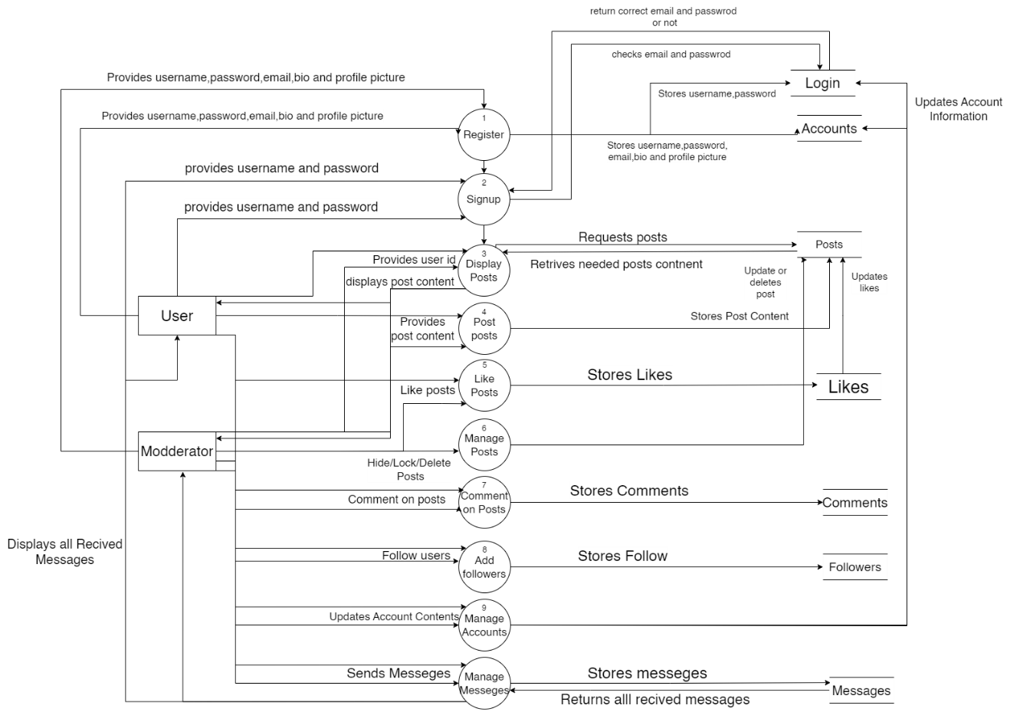

Figure :Level 1 DFD of Blogging System

The level 1 DFD of the Blogging system is given above. This diagram shows the proceeses and function of the system in detail along with the expected input and outputs that the system requires.This diagram shows how the different processes of the system funxtion. It also displays the expected iutputs given by the system

## System Design

The design uses a three-tier structure to separate the layers and improve performance. The presentation layer uses HTML and CSS to properly present the website across devices. The logical gayer uses PHP to facilitate communication between the presentation layer and the database. MySQL is the database used to store the data. JavaScript is also used to improve the user experience

### Architectural Design

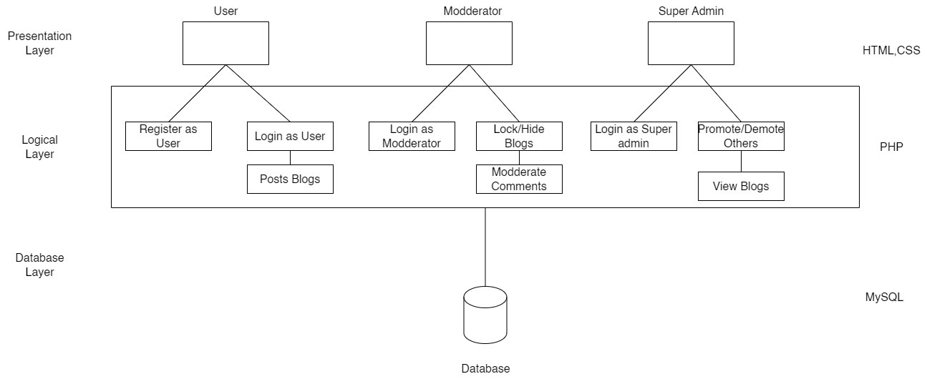

Figure :Architectural Design of Blogging System

The Architectural Design of the Blogging system is given above. This diagram shows the three-tier architecture used in the system along with the different tools/languages used in each layer along with some of the functions of the users. Theis system uses MySQL as the main database in the database layer. It also uses PHP as the principle language to facilitate communication between the presentation layer and the database layer. The use of HTML and CSS alongside JavaScript in the presentation layer helps the system to be faster.

### Database Schema Design

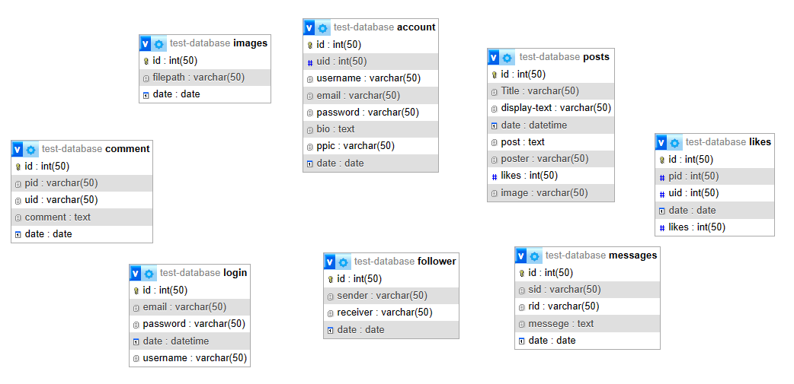

Figure :Database Schema Design of Blogging System

### Interface Design

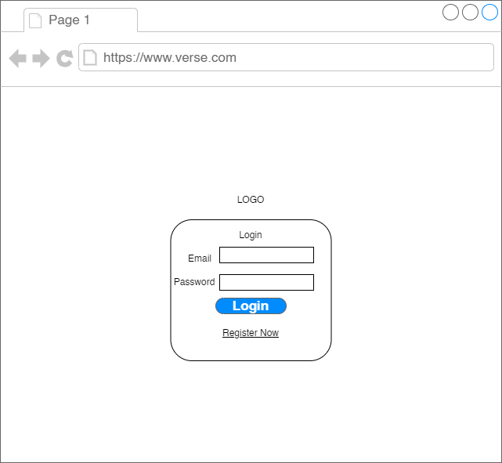

Figure :UI Design of Login page of Blogging System

The interface of the login page is shown in the above figure. Here, the user will login if the users email and password are correct and the login button is pressed

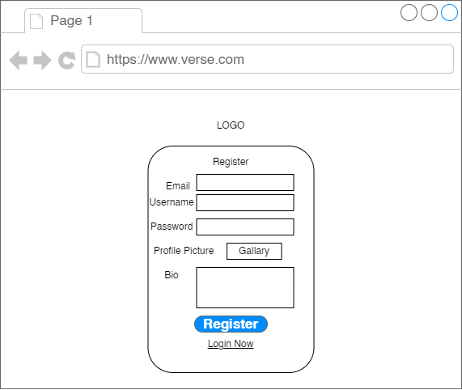

Figure :UI Design of Register page of Blogging System

The interface of the Register page is shown in the above figure. Here, the user will register if all relevenant information are presented and the register button is clicked

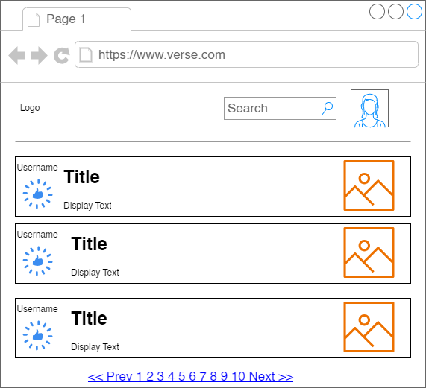

Figure ::UI Design of Display page of Blogging System

The interface of the display page is shown in the above figure. Here, the user will be shown the posts of the users they have followed.

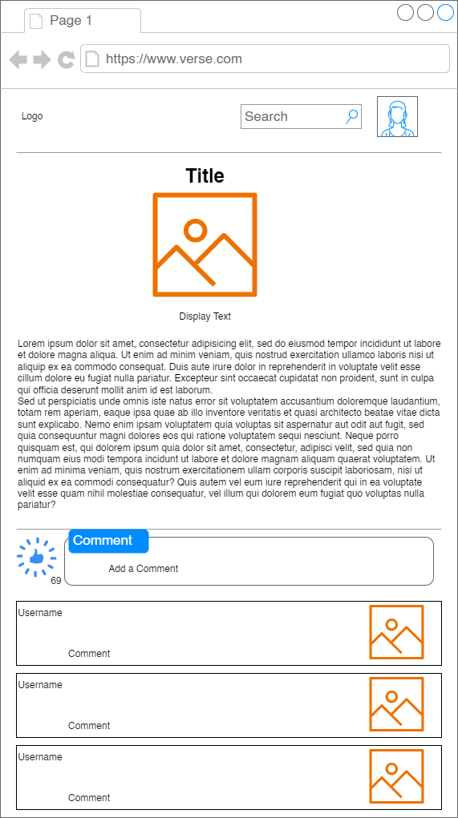

Figure ::UI Design of Display-Post page of Blogging System

The interface of the display post page is shown in the above figure. Here, the user will see the post details.

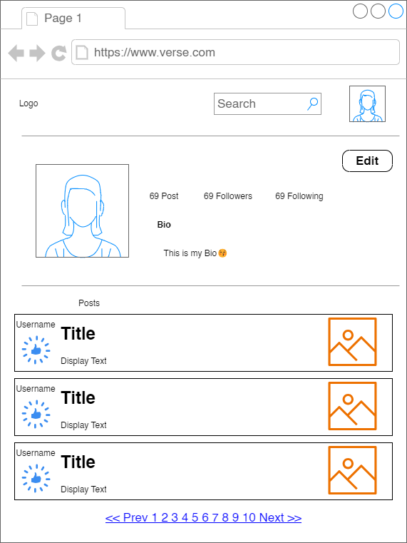

Figure ::UI Design of Account page of Blogging System

The interface of the account page is shown in the above figure. Here, the user is shown the users details and the posts they have

### Physical DFD

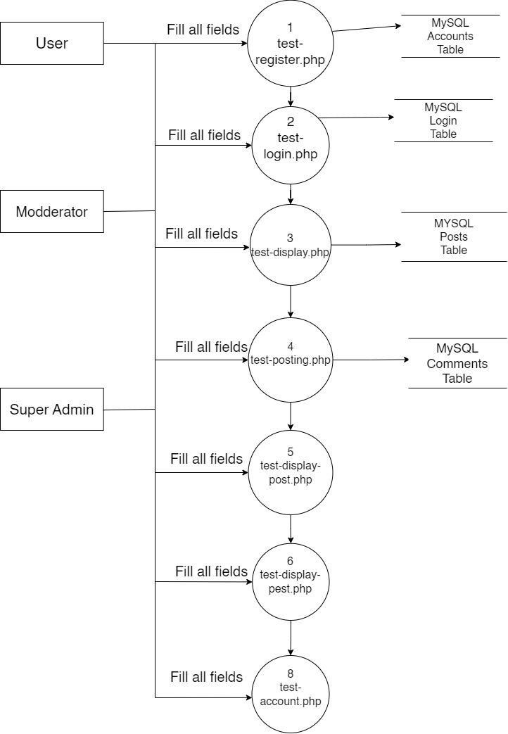

Figure :Physical DFD of Blogging System

The physical DFD of the Blogging system is given above

# Chapter 4 IMPLEMENTATION AND TESTING

## Implementation

The implementation phase involves the application of design specifications done before. The implementation involves coding of the system designs if this project, systems testing is live and running. During implementation we start coding according to our requirement.

### Tools Used

This project is developed using the tools, which are most suited for development of the PSTU web-based system. These tools are as follows:

* HTML (For developing the basic structure of the site)
* CSS (for designing and styling the html page)
* JavaScript (for making the site more responsive and adding additional functions)
* PHP (For interacting with database)
* MYSQL (For database Storage)

### Implementation Details of Modules

There are various modules present in this system. They are

* Login Module

The Login module facilitates the login process for registered users. The user provides their username and password which will lead them to the system.

* Register Module

The Register module facilitates the registration process for new users. The user provides information such as username, email, profile picture etc.

* Post Module

This module allows the user to post posts. The user provides information such as title, text image which is then stored and displayed to other users.

* Display Module

This module allows the user to see the post other users have posted. This allows users to read other people's blogs

* Account Module

This module allows the user to see their own account. This allows the user to change their username, password, profile picture etc.

## Testing

The testing section is accomplished to validate the Blogging system. The Blogging system is examined to test if the final system can work in keeping with what we have been waiting for and is free from any programming and logical errors. It additionally makes sure whether or not all of the system and requirements are met or not.

### Test Cases for Unit Testing

Unit testing is a software program development method in which the smallest testable components of an application, known as units, are individually and independently scrutinized for correct operation. Below are the numerous tables for distinctive test case.

Table :Test case for Register module

|  |  |  |  |  |
| --- | --- | --- | --- | --- |
| **S.N** | **Test Case** | **Input** | **Expected Outcome** | **outcome** |
| 1 | Navigate to Register page | Path: http://localhost/codes/4th%20sem/unit-2-php/test/test-register.php | Register page should open | As expected, Member is navigated to register in page of system |
| 2 | Provide own details | Email, username, password, profile picture, bio | Credential should be entered | As expected, |
| 3 | Click register Button | Button clicked | User should be registered | As Expected, |

Table :Test case for Login module

|  |  |  |  |  |
| --- | --- | --- | --- | --- |
| **S.N** | **Test Case** | **Input** | **Expected Outcome** | **outcome** |
| 1 | Navigate to Login page | Path: http://localhost/codes/4th%20sem/unit-2-php/test/test-login.php | Login page should open | As expected, Member is navigated to login page of system |
| 2 | Provide details | Email and password | Credential should be entered | As expected, |
| 3 | Click login Button | Button Clicked | User should log in | User is logged in |
| 4 | Provide wrong email | Wrong email and password | Credential should be entered | As expected, |
| 5 | Navigate to register page | Link to go to register page is clicked | Register page should open | As expected, Member is navigated to register page of system |

Table Test Case for Dispaly Post Module

|  |  |  |  |  |
| --- | --- | --- | --- | --- |
| **S.N.** | **Test case** | **Input** | **Expected Outcome** | **Output** |
| 1 | Redirected from test case | Button clicked | Success | As expected |
| 2 | Like post | Button clicked | If previously like unlike and vise versa | As expected |
| 3 | Display comments | Button Click | Comment should be displayed | As expected |
| 4 | Post comments | Comment text | Comment should be posted | As expected |

### Testing for account edit module:

Table 4 Account edit testing

|  |  |  |  |  |
| --- | --- | --- | --- | --- |
| **sn** | **Test Case** | **Test Data** | **Expected Outcome** | **outcome** |
| 1 | Change Email | Email | Emil is changed | As expected |
| 2 | Change Password | Password | Password is changed | As expected |
| 3 | Change bio | Profile bio | Bio is changed | As expected |
| 4 | Change username | Username | Username is changed | As expected |
| 5 | Change profile picture | Profile picture | Profile picture is changed | As expected |

### Testing for account module

Table 5 Account module Testing

|  |  |  |  |  |
| --- | --- | --- | --- | --- |
| **Sn** | **Test Case** | **Test Data** | **Expected Outcome** | **Outcome** |
| 1 | Check Followed | Username | Followed is shown | It did not show |
| 2 | Check Followers | Username | Followers is shown | It did not show |
| 3 | Edit Account | Username, password, email  Profile picture, bio | Account is edited | As expected |
| 4 | Strike Account | Username, email | Account is striked | As expected |

### Test Cases for System Testing

System Testing is a from of software testing that is executed on a complete integrated system to assess the compliance of the system with the corresponding requirements.

Table :System Testing

|  |  |  |  |  |
| --- | --- | --- | --- | --- |
| **Sn** | **Test Case** | **Test Data** | **Expected Outcome** | **outcome** |
| 1 | Check Register | Username, password, email  Profile picture, bio | User register | As expected |
| 2 | Check Login | Email, password | User login | As expected |
| 3 | Check display |  | Displays posts of all followed people | As expected |
| 4 | Check Posts | Title, display text, actual text, image | Post created and saved | As expected |
| 5 | Like posts | Button clicked | Post liked if unliked before, unliked if liked before | As expected |
| 6 | Find other users | username | Redirected to searched user account | failure |
| 7 | Comment on post | Comment text | Comment added | As expected |

# Chapter 5 CONCLUSIONS AND FUTURE RECOMENDATION

## Lesson Learnt

In creating the online blogging system, we've learned some important lessons. First, listening to users and making changes based on their feedback is crucial for improving the platform. Second, ensuring accessibility for all users, including those with disabilities, is essential. Third, having effective tools for content moderation helps maintain a positive community atmosphere. Lastly, staying adaptable and keeping up with trends is key for the platform's success in a fast-changing digital world.

## Conclusion

In conclusion, the development of an online blogging system represents a significant opportunity to harness the power of digital technology for creative expression, information sharing, and community building. By providing users with user-friendly platforms to publish content, interact with audiences, and explore diverse topics, online blogging systems empower individuals and organizations to amplify their voices and connect with others on a global scale. While challenges such as content moderation, monetization, and accessibility remain, the evolving landscape of blogging continues to offer exciting possibilities for innovation and collaboration. As we move forward, it is essential to prioritize user experience, inclusivity, and ethical practices to ensure that online blogging systems continue to thrive as vibrant and valuable tools for communication and engagement in the digital age.

## 5.3. Future Recommendations

As the Project comes up with some limitation which can be improved in future and further more advancement can also be made. The different features that can be added are as follows:

* The system could support video uploads as well.
* The system could provide payment and run ads in the system.
* The system could add a live chatting feature.

# APPENDICES

Login Page

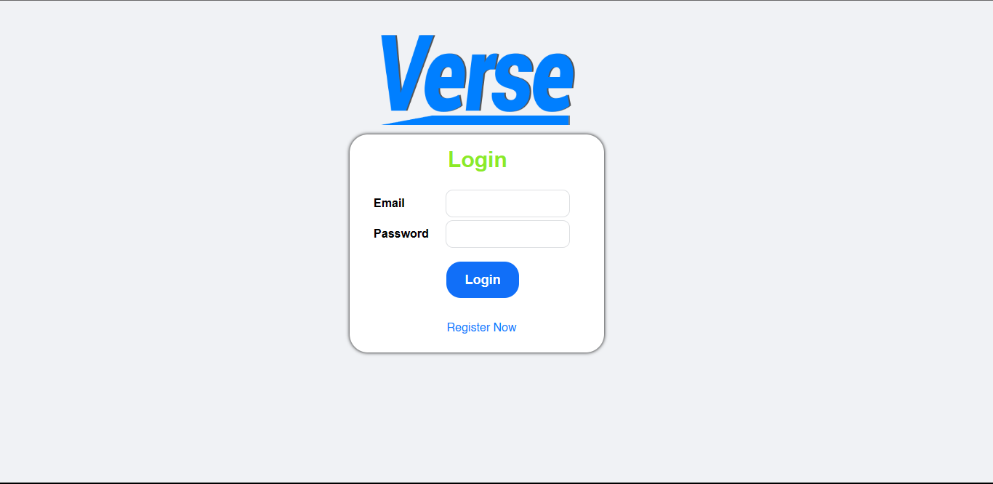

Register Page

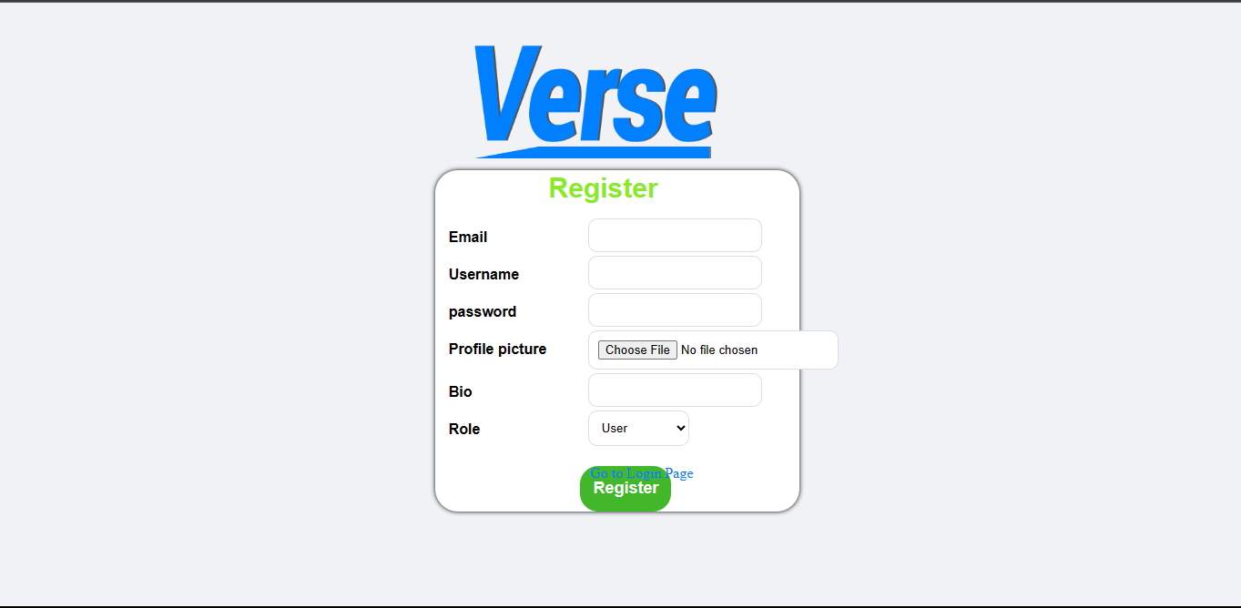

Display Page

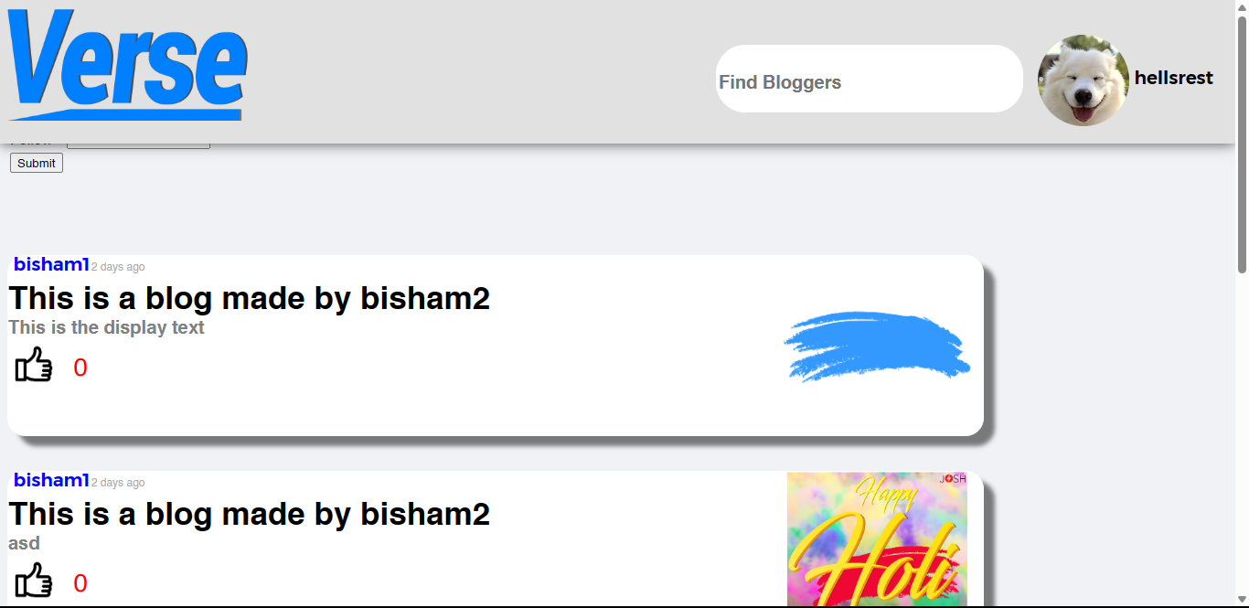

Display Post Page

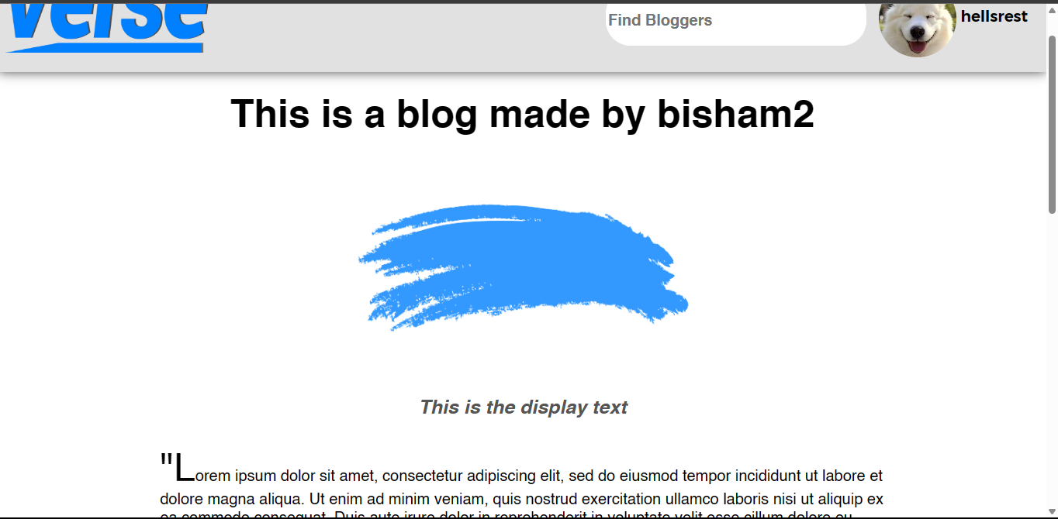

# Bibliography

|  |  |
| --- | --- |
| [1] | H. (. Zou and Ken Hyland, "www.aelfe.org," 2020. [Online]. Available: http://www.aelfe.org/documents/39_11_IBERICA.pdf. [Accessed 19 4 2024]. |
| [2] | S. M. A. N. S. A. K. Sahil Hans, "A Systematic Review of Blogging : Opportunities and Challenges," *International Journal of Scientific Research in Computer Science, Engineering and Information Technology,* vol. 7, no. 3, pp. 123-129, June 2021. |
| [3] | A. Java, X. Song, T. Finin and B. Tseng, "Why We Twitter: Understanding Microblogging," 12 August 2007. [Online]. Available: https://ebiquity.umbc.edu/_file_directory_/papers/369.pdf. [Accessed 1 March 2024]. |
| [4] | R. Blood, 7 september 2000. [Online]. Available: http://www.rebeccablood.net/essays/weblog_history.html. [Accessed 15 2 2024]. |
| [5] | S. Herring, L. Scheidt, S. Bonus and E. Wright, "Bridging the Gap: A Genre Analysis of Weblogs," January 2004. [Online]. Available: https://www.researchgate.net/publication/261299701_Bridging_the_Gap_A_Genre_Analysis_of_Weblogs. [Accessed 12 2 2024]. |
| [6] | B. A. Nardi, D. J. Schiano, M. Gumbrecht, L. Swart and L. Swart, "Why we Blog," 1 December 2004. [Online]. Available: https://dl.acm.org/doi/pdf/10.1145/1035134.1035163. [Accessed 18 2 2024]. |
| [7] | P. Jalotke, An Intregrated Approach to software enginieering, 1991. |

# 